|  |  |
| --- | --- |
| **Exp No: 7**  **Date: 24.04.25** | **LIBRARY MANAGEMENT SYSTEM** |

**AIM:**

Write a program to implement a library management system

**PROGRAM:**

**LIBRARAYMANAGAEMENT.JSP**

<%@ page import=*"java.sql.*"* %>

<%@ page contentType=*"text/html;charset=UTF-8"* language=*"java"* %>

<html>

<head>

<title>Library Management - Add Book</title>

<style>

**body** {

font-family: *Arial, sans-serif*;

background-color: *#f3f3f3*;

margin: *20px*;

padding: *20px*;

}

**h2** {

color: *#333*;

}

**form** {

background-color: *#fff*;

padding: *20px*;

border-radius: *8px*;

box-shadow: *0 2px 5px rgba(0,0,0,0.1)*;

width: *400px*;

}

**input**[type="text"]**,**

**input**[type="number"]**,**

**select** {

width: *100%*;

padding: *8px*;

margin: *6px 0 12px 0*;

border: *1px solid #ccc*;

border-radius: *4px*;

}

**input**[type="submit"] {

background-color: *#4CAF50*;

color: *white*;

border: *none*;

padding: *10px 16px*;

cursor: *pointer*;

border-radius: *4px*;

}

**input**[type="submit"]*:hover* {

background-color: *#45a049*;

}

**p** {

font-size: *16px*;

}

**a** {

color: *#007BFF*;

text-decoration: *none*;

}

**a***:hover* {

text-decoration: *underline*;

}

</style>

<script>

**function** validateForm() {

**const** bookId = document.getElementById("bookId").value.trim();

**const** title = document.getElementById("title").value.trim();

**const** author = document.getElementById("author").value.trim();

**const** year = document.getElementById("year").value.trim();

**const** category = document.getElementById("category").value;

**const** copies = document.getElementById("copies").value.trim();

**const** currentYear = **new** Date().getFullYear();

**if** (!/^[a-zA-Z0-9]+$/.test(bookId)) {

alert("Book ID must be alphanumeric.");

**return** **false**;

}

**if** (!/^[A-Za-z ]+$/.test(title)) {

alert("Title must contain only letters.");

**return** **false**;

}

**if** (!/^[A-Za-z ]+$/.test(author)) {

alert("Author name must contain only letters.");

**return** **false**;

}

**if** (!/^\d{4}$/.test(year) || parseInt(year) > currentYear) {

alert("Year must be a valid 4-digit year.");

**return** **false**;

}

**if** (category === "") {

alert("Please select a category.");

**return** **false**;

}

**if** (isNaN(copies) || parseInt(copies) <= 0) {

alert("Copies must be a positive number.");

**return** **false**;

}

**return** **true**;

}

</script>

</head>

<body>

<h2>Add Book to Library</h2>

<form method=*"post"* onsubmit="return validateForm()">

Book ID: <input type=*"text"* name=*"bookId"* id=*"bookId"*/><br/>

Title: <input type=*"text"* name=*"title"* id=*"title"*/><br/>

Author: <input type=*"text"* name=*"author"* id=*"author"*/><br/>

Year: <input type=*"text"* name=*"year"* id=*"year"*/><br/>

Category:

<select name=*"category"* id=*"category"*>

<option value=*""*>--Select--</option>

<option value=*"Science"*>Science</option>

<option value=*"Fiction"*>Fiction</option>

<option value=*"History"*>History</option>

</select><br/>

Copies: <input type=*"number"* name=*"copies"* id=*"copies"*/><br/><br/>

<input type=*"submit"* value=*"Add Book"*/>

<p>

<label>Book Details:-</label>

<a href=*"./display_books.jsp"*>Click Here</a>

</p>

</form>

<%

// JSP Database logic

// TODO:Change password before run the code

// TODO: CREATE THE TABLE IN MYSQL

/**

CREATE TABLE books (

book_id VARCHAR(20) PRIMARY KEY,

title VARCHAR(100),

author VARCHAR(100),

year INT,

category VARCHAR(50),

copies INT

);

**/

String bookId = request.getParameter("bookId");

**if** (bookId != **null**) {

String title = request.getParameter("title");

String author = request.getParameter("author");

String year = request.getParameter("year");

String isbn = request.getParameter("isbn");

String category = request.getParameter("category");

String copies = request.getParameter("copies");

**try** {

Class.forName("com.mysql.cj.jdbc.Driver");

Connection conn = DriverManager.getConnection(

"jdbc:mysql://localhost:3306/library_management_akshayaas", "root", "");

PreparedStatement ps = conn.prepareStatement(

"INSERT INTO books (book_id, title, author, year, category, copies) VALUES (?, ?, ?, ?, ?, ?)");

ps.setString(1, bookId);

ps.setString(2, title);

ps.setString(3, author);

ps.setInt(4, Integer.parseInt(year));

ps.setString(5, category);

ps.setInt(6, Integer.parseInt(copies));

**int** result = ps.executeUpdate();

**if** (result > 0) {

%>

<script>alert("Book Added Successfully!!")</script>

<%

} **else** {

%>

<script>alert("Failed to add book!!")</script>

<%

out.println("<p style='color:red;'>Failed to add book.</p>");

}

ps.close();

conn.close();

} **catch** (Exception e) {

out.println("<p style='color:red;'>Error: " + e.getMessage() + "</p>");

}

}

%>

</body>

</html>

DISPLAY_BOOKS.JSP

<%@ page import=*"java.sql.*"* %>

<%@ page contentType=*"text/html;charset=UTF-8"* language=*"java"* %>

<html>

<head>

<title>Library Books List</title>

<style>

**table** {

border-collapse: *collapse*;

width: *90%*;

margin: *20px auto*;

}

**th,** **td** {

border: *1px solid #333*;

padding: *10px*;

text-align: *center*;

}

**th** {

background-color: *#f2f2f2*;

}

**h2** {

text-align: *center*;

}

</style>

</head>

<body>

<h2>All Books in Library</h2>

<%

**try** {

Class.forName("com.mysql.cj.jdbc.Driver");

Connection conn = DriverManager.getConnection(

"jdbc:mysql://localhost:3306/library_management_akshayaas", "root", "");

Statement stmt = conn.createStatement();

ResultSet rs = stmt.executeQuery("SELECT * FROM books");

out.println("<table>");

out.println("<tr><th>Book ID</th><th>Title</th><th>Author</th><th>Year</th><th>Category</th><th>Copies</th></tr>");

**while** (rs.next()) {

out.println("<tr>");

out.println("<td>" + rs.getString("book_id") + "</td>");

out.println("<td>" + rs.getString("title") + "</td>");

out.println("<td>" + rs.getString("author") + "</td>");

out.println("<td>" + rs.getInt("year") + "</td>");

out.println("<td>" + rs.getString("category") + "</td>");

out.println("<td>" + rs.getInt("copies") + "</td>");

out.println("</tr>");

}

out.println("</table>");

rs.close();

stmt.close();

conn.close();

} **catch** (Exception e) {

out.println("<p style='color:red;text-align:center;'>Error: " + e.getMessage() + "</p>");

}

%>

</body>

</html>

**OUTPUT:**

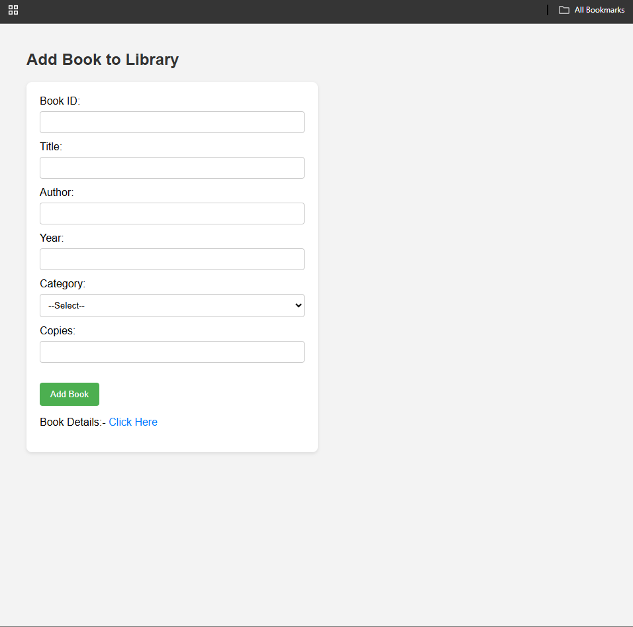

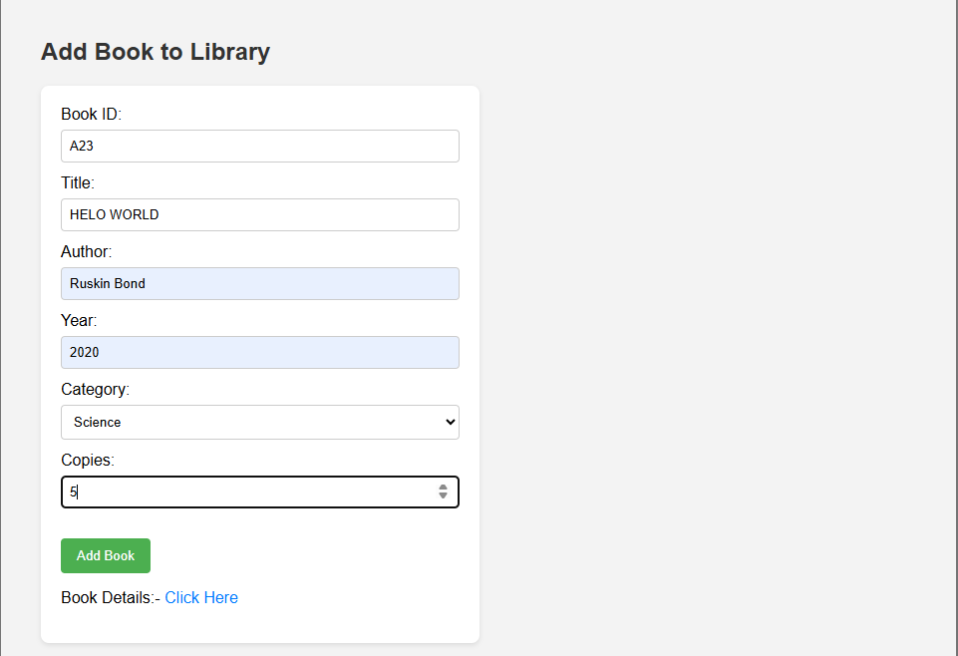

**RESULT :**Thus the experiment to implement the library management system has been successfully implemented and verified